J16. RAPHAEL TUCK

J16A OILETTE SERIES 7478 [n.l. 1906]

At A.H. Fullwood
Pu Raphael Tuck & Sons Ltd.
Pr In Great Britain (by Tucks)
F Printed from oil painting with title and artist's name superimposed. Sold as a packaged set (see illustration)
J16A.1 Australia-/The Crystal City, Jenolan Caves, N.S.W. H  J16A.2 Australia-/Nellie's Grotto, Jenolan Caves, N.S.W. H [pm.20 May 1909]  J16A.3 Australia-/The Willows, Jenolan Caves, N.S.W. H [pm.1 Jul.1907]  J16A.4 Australia-/Jenolan Caves, The Devil's Coach-house, N.S.W. V  J16A.5 Australia-/Imperial Cave, Jenolan Caves, N.S.W. V [pm.7 Jan.1906]  J16A.6 Australia/The Hotel - Jenolan Caves, N.S.W. V [pm.30 Aug.1906] | 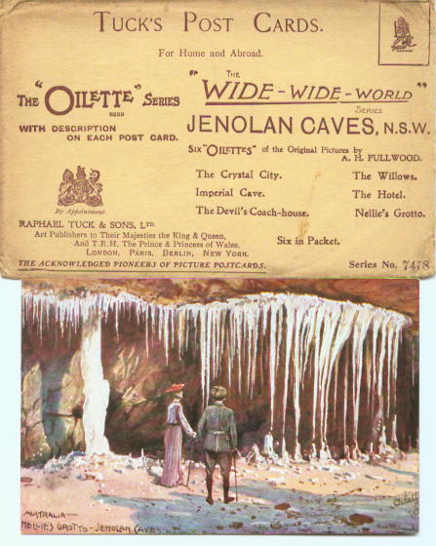

J16B. TUCK other [n.l. 1907]

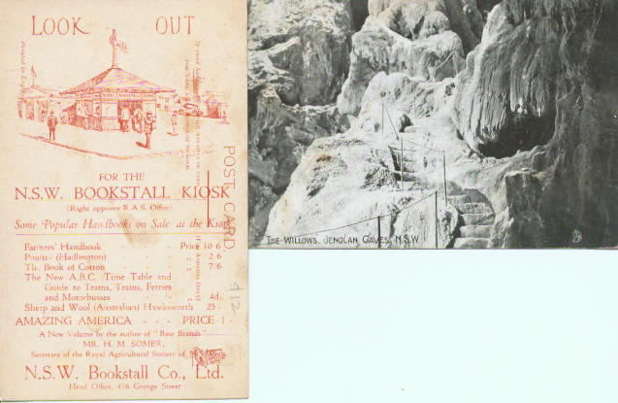

Pu Raphael Tuck & Sons Ltd.
Pr In Great Britain
F B. & W. halftone with title and Tuck trademark (easel, palette & brushes) superimposed in lower R.H. corner of picture. Note: trademark is only identification on card.

J16B.1 "The Willows", Jenolan Caves, N.S.W. H [pm.13 Dec.1906]
One of us also has this card with an advertisement for the N.S.W. Bookstall Co., overprinted in red on the back.

